***Nuclear Weapons Are Not a Fact of Life*** Dec. 26, 2024 The New York Times

*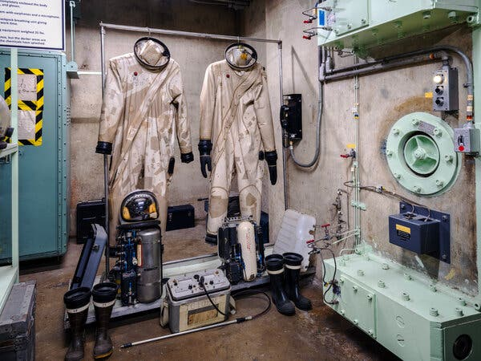By Beatrice Fihn*

Ms. Fihn is the director of Lex International Fund and a former executive director of the Nobel Peace Prize-winning International Campaign to Abolish Nuclear Weapons(ICAN).

**AAA永井**

It’s easy to feel overwhelmed by the growing risk of nuclear war today. Russia is making regular nuclear threats. America is undertaking a large-scale nuclear modernization program. China is increasing its nuclear arsenal. Tensions are escalating between nuclear-armed states.

But nuclear weapons are not an inevitable fact of human life. They are not impossible to get rid of, and pushing for that can be done by ordinary people like you and me.

Precedent exists for solving the problem of weapons of mass destruction. At one point, the United States and the Soviet Union, then Russia, together had over 70,000 tons of chemical weapons. But on July 7, 2023, the [United States announced](https://councilonstrategicrisks.org/2023/11/21/destruction-and-beyond/) it had destroyed the last of its chemical weapon stockpiles, under the 1997 Chemical Weapons Convention. Russia declared it had done so a few years earlier.

When nations violate such treaties — such as when Syria, a party to the treaty, used chemical weapons in 2018 — they see little benefit but can quickly bring on international condemnation. Syria’s strategic position didn’t suddenly improve because it employed a weapon of mass destruction. The world perceives chemical and biological weapons as very dangerous but not as a source of power.

Nuclear weapons can lose their power, too. Contrary to popular belief, nuclear weapons are remarkably inefficient tools of war. They are clumsy and expensive and lack practical military utility. Their use would result in catastrophic destruction, potentially wiping out hundreds of thousands of innocent civilians and spreading radioactive contamination across borders and generations. **It is hard to envisage a scenario in which a state would be better off choosing to use a nuclear weapon over a conventional weapon, given the significant harm it would cause both to that nation and to its allies. Even nuclear-armed nations openly acknowledge that these weapons should never be used.**

**BBB中島（宮武）**

**As opposed to conventional weapons, nuclear weapons’ main perceived benefit lies in their ability to scare and deter others. Their power lies not in their practical utility but in how they are viewed by nations and their adversaries. This concept, known as nuclear deterrence, works only as long as your adversaries allow it to work; it is a profoundly vulnerable security strategy.**

That vulnerability is our greatest opportunity for change. Since no other weapon is so dependent on public perception, regular people have a unique power over the future of these weapons. Ukrainians’ refusal to be deterred by Russia’s threats of using a nuclear weapon is one example of how regular people can shift perceptions of nuclear threats and reduce the impact of a nation’s nuclear arsenal. When the threats are ignored, they lose their potency.

The anti-nuclear-weapon movement has achieved many victories in restraining nuclear proliferation and preventing nuclear war this way. Student groups, trade unions, professional organizations, scientists, artists and local governments have all played crucial roles in challenging the nuclear status quo. Thanks in part to political pressure and shifts in perception generated by such grass-roots movements, most countries in the world have signed on to a world without nuclear weapons through nuclear-weapon-free zones and the United Nations’ Treaty on the Prohibition of Nuclear Weapons. The United States and Russia have reduced their nuclear stockpiles by over 80 percent since 1985. Nuclear testing, with the exception of North Korea, has ceased. Since 1945, no country has used nuclear weapons in warfare. The number of nuclear-armed states remains small — just nine out of 193 United Nations member states. Not having nuclear weapons is the norm, not the exception.

**CCC南井**

Consider the pivotal moments of nuclear activism in America. In the 1980s, 25 of the largest U.S. trade unions supported the nuclear freeze movement, which sought to stop and reverse the nuclear arms race between the United States and the Soviet Union. Professional organizations like International Physicians for the Prevention of Nuclear War mobilized medical professionals. Artists, including Bruce Springsteen, created cultural moments like the “No Nukes” concerts at Madison Square Garden in 1979. Filmmakers, such as those who made the influential film “The Day After,” helped shift public perception and even influenced political leaders, Ronald Reagan among them. Local engagement was particularly powerful; in 1982 several states, hundreds of city governments and over 400 town halls in New England passed freeze resolutions.

Today we’re seeing new opportunities for action, spearheaded by the International Campaign to Abolish Nuclear Weapons, an organization that I led from 2014 to 2023 and that was awarded the 2017 Nobel Peace Prize. Films like “Oppenheimer” and the upcoming “Last Train From Hiroshima” are bringing the threat of nuclear weapons back into public consciousness.

So how can individuals contribute? First, recognize your power. A key tool is to change the way we talk about nuclear weapons. Instead of thinking of them as magical tools, we should talk about them as being irrational and useless for any real life military situation. Instead of discussing nuclear weapons in terms of abstract theoretical concepts like strategic stability and mutually assured destruction, we should center conversations on the facts and scientific evidence of what happens when these weapons are used or tested. **We can all start questioning common assumptions that these weapons are designed to keep us safe and expose the irrationality of a national security strategy based on threatening to commit collective global suicide.**

**DDD村上**

If you’re a student, organize campus discussions. If you’re a professional, engage through your networks. If you are an artist, use your skills to address these issues.

Get in touch with your elected representatives but don’t **forget to** also engage with city councils, state representatives and community groups. Cities and local authorities are becoming more involved in statecraft and diplomacy. **Getting your city or state on board with the growing number of local authorities that are taking action on this can help build a new generation of political leaders taking on this issue.**

Finally, remember that it’s not just governments that need to change. Through our pension funds, universities and financial institutions, we can try to influence corporate behavior by withdrawing investments from companies involved with nuclear weapon manufacturing. **By pressuring companies like Boeing, Lockheed Martin, Northrop Grumman and other military contractors that develop nuclear weapon technologies, we can make the production of weapons of mass destruction costly to corporate reputations. Divestment campaigns** have proved effective at raising awareness in other spheres, such as tobacco and fossil fuels, and can be equally helpful in delegitimizing nuclear weapon production.

War is on the rise, and escalating global tensions might feel insurmountable. But the history of how we have slowed proliferation and reduced weapons of mass destruction proves that collective action can transform seemingly impossible situations. **The path** forward is not through fear but through persistent, collaborative effort. Every conversation, every local resolution, every piece of art that challenges nuclear myths contributes to a larger movement.

We have the power to turn nuclear weapons into relics of a misguided past.